Vernacular Names: Narrow-leafed bird lime tree | Scientific Name: Cordia subcordata Lam.
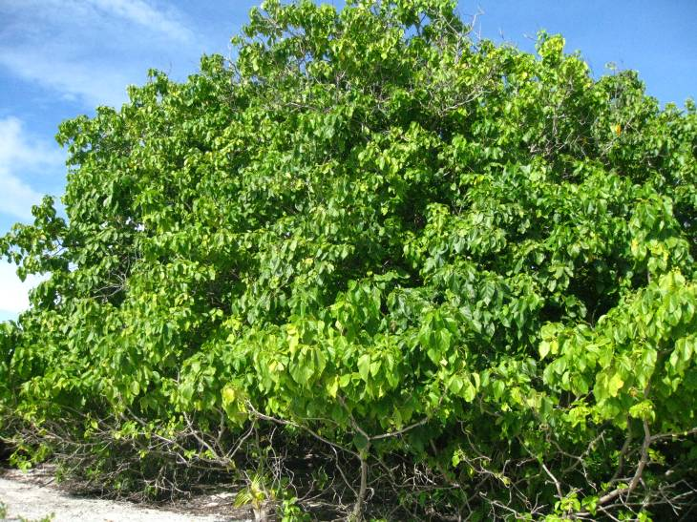 | 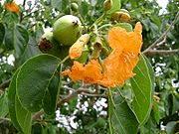  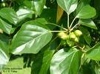
Full tree form | Details of leaf, flower, & fruit
Native or Introduced: Native

Description: The tree grows to 7–10 metres at maturity, but may be as tall as 15 metres. It has ovate leaves that are 8–20 centimetres long and 5–13 centimetres wide. The tubular flowers are 2.5–4 centimetres in diameter and form heads. Petals are bright orange and the sepals are pale green. Blooming occurs throughout the year. Fruit is produced year round and is spherical, 2–3 centimetres long and woody when mature. Each fruit contains four or fewer seeds that are 10–13 millimetres long. The fruit are buoyant and may be carried long distances by ocean currents. The large shiny leaves can be confused with other species, but the orange flowers identify the tree absolutely.

Habitat: These trees are found on the coast, and can be very tolerant of rocky ground and saline conditions. Easily seen at Turtle Cove.

Human uses: The seeds are edible and have been eaten during famine. The wood burns readily, and this lead to the nickname of Kerosene Tree in Papua New Guinea. The wood of the tree is soft, durable, easily worked, and resistant to termites. In ancient Hawaii the wood was used to make bowls, utensils, and large calabashes because it did not impart a foul taste to food. The flowers were used to make lei (flower necklaces), while a dye for kapa cloth and aho (fishing lines) was derived from the leaves.

Significance: Small tree, fast growing to a shrub stage, then slow to a large size, good nursery species to protect slower growing trees beneath its shade. Some specimens on the Turtle Cove peninsulas are very large, with evidence they were used for canoe building in the past.

Propagation: Seeds; cuttings possibly?

